

ASSIGNMENT

# Introduction to Software Engineering



## Submitted To: Sir Shakir Rasheed

## Submitted by: Sardar Munaqib

Roll No: 4306-FBAS/BSSE-F21/B

Sequence Diagram for Employee Management System:

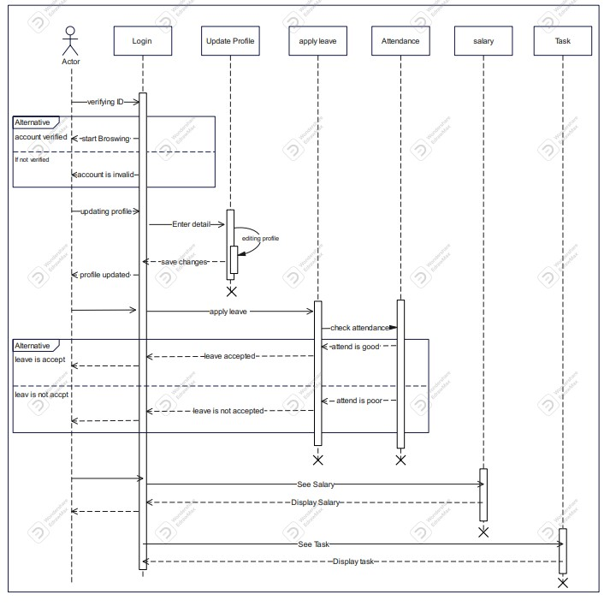

Class Diagram For Employee Management System:

